**

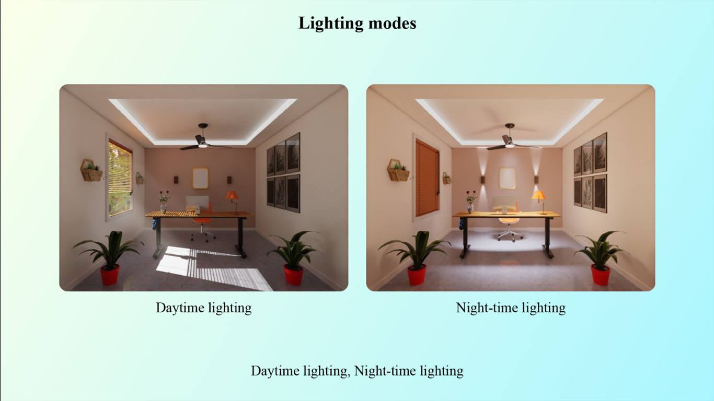

Subject: Enhance Ambiance with Daylight and Nighttime Lighting Modes in VisCommerce's 3D Room Planner Tool

Dear [Recipient's Name],

I trust this email finds you well. I wanted to highlight a captivating feature of VisCommerce's 3D Room Planner Tool that holds the potential to transform how we create and showcase immersive experiences. The introduction of Daylight and Nighttime lighting modes offers an exciting opportunity to enhance ambiance and provide a more comprehensive understanding of our products within both home and store 3D environments.

In the realm of online retail, offering a diverse range of visual experiences is essential to engaging customers effectively. The Daylight and Nighttime lighting modes within VisCommerce's 3D Room Planner Tool allow us to create tailored atmospheres that cater to various preferences and scenarios.

**Here's how these lighting modes can elevate our product presentation:**

* **Daylight Lighting Mode:** This mode replicates the natural illumination of daylight, showcasing our products in a bright and inviting setting. Customers can explore how products appear under different levels of natural light, helping them make informed decisions about colors, textures, and overall aesthetics.
* **Nighttime Lighting Mode:** The Nighttime lighting mode creates a cozy and atmospheric setting, simulating the ambiance of an evening environment. This mode is perfect for demonstrating how our products can contribute to a warm and inviting atmosphere after dusk, making it particularly relevant for items such as lighting fixtures and décor.
* **Comprehensive Visual Insights:** By toggling between these lighting modes, customers can gain a holistic perspective of how our products fit into their living spaces throughout the day. This capability not only adds to the immersive experience but also assists in making choices that harmonize with their lifestyle and preferences.
* **In-Store Application:** For our physical store environments, the Daylight and Nighttime lighting modes provide a glimpse into how our products would appear in various lighting conditions. This feature enables customers to assess the versatility of our offerings and make selections that align with different room atmospheres.
* **Customer Engagement:** The introduction of these lighting modes enhances the interactive aspect of our 3D Room Planner Tool. Customers can explore different moods and scenarios, fostering a deeper connection with the products and boosting their engagement with our brand.

I am genuinely excited about the potential that the Daylight and Nighttime lighting modes bring to our product showcasing efforts. By offering customers the ability to visualize our products in multiple lighting scenarios, we're not just selling items; we're enabling them to envision the way these products can transform their living spaces.

If you're interested in learning more about these lighting modes and how they can seamlessly integrate into our existing strategies, I'd be delighted to provide further insights or arrange a demonstration.

Thank you for your time, and I eagerly await your thoughts.

Best regards,